Homework M3

1. There is my vagrant file - https://pastebin.com/AgNW9C1j
2. Here is my docker-compose.yml - https://pastebin.com/QW8j5Gzy

After I setup my vagrant file I run it so I can automated as much as possible:
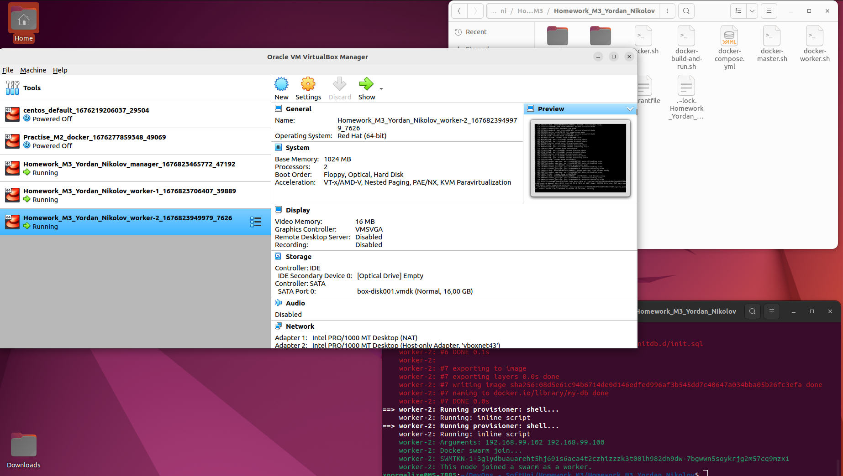

My Images are prebuild in the vagrant file from this Dockerfiles:
PHP Dockerfile:
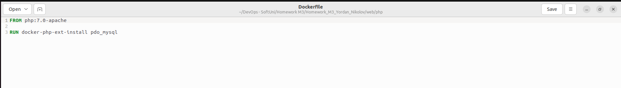
MySQL Dockerfile:
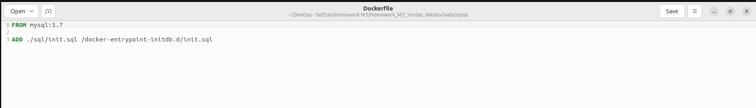
After The swarm cluster is ready I run on the manager VM the following command to deploy the docker -compose.yml file :
docker stack deploy -c docker-compose.yml website

And Finally I try the result with the
docker stack ps website

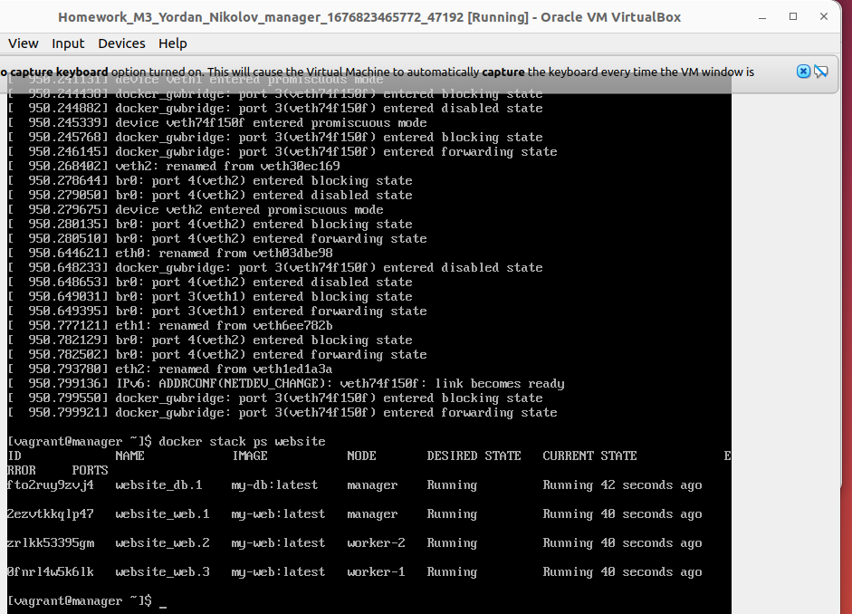
Final Result:
